NAME : NIKHIL PASSI

BTE ROLL NO : 1912111045

CLASS ROLL NO : 344



**PRACTICAL -4**

**AIM:** write the program with DDA algoritham in c language

***Code:*** 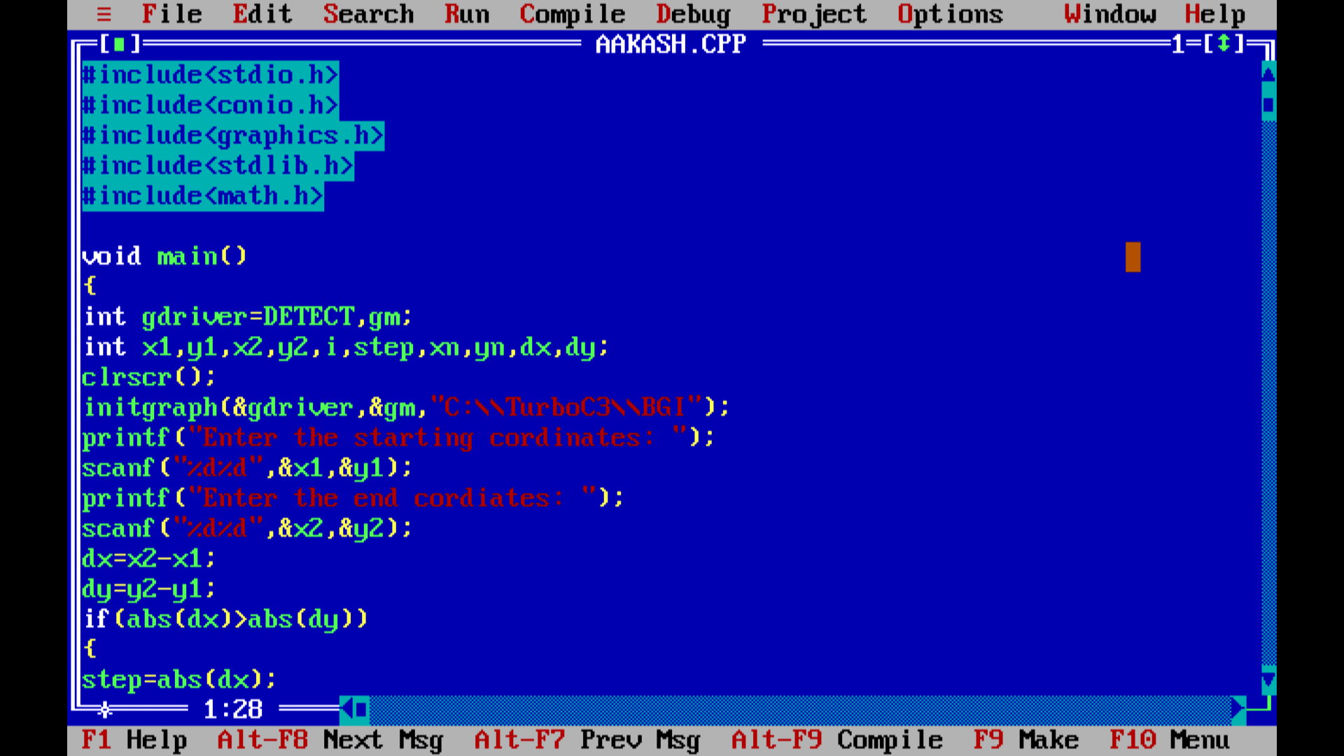

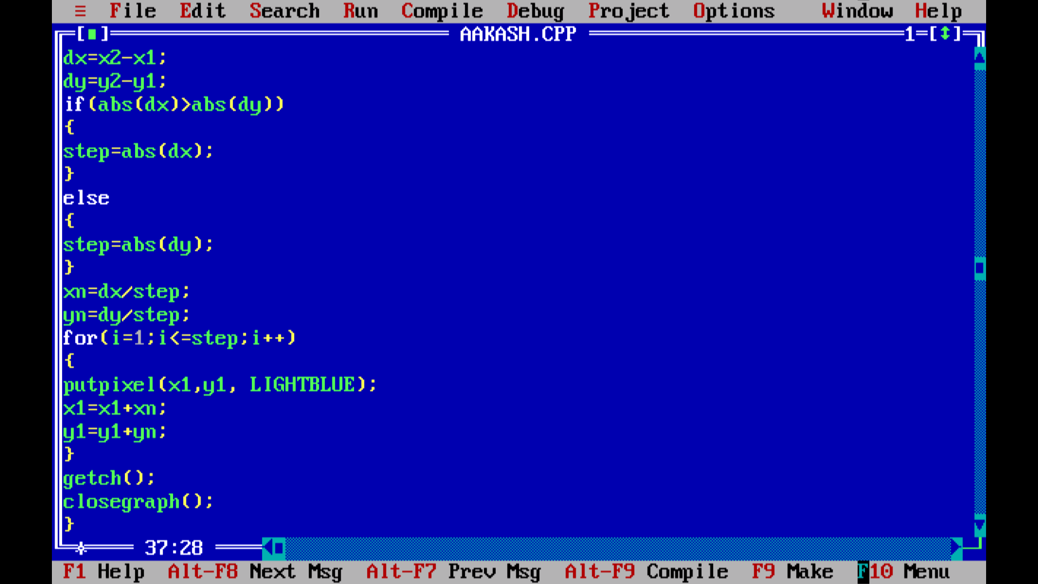

***Output:*** 